Roasted Vegetable Recipes

How to Make Roasted Vegetables?
- Preheat the oven to 400 degrees. Place vegetables on a rimmed baking sheet with tin foil for easy clean up. Drizzle olive oil and seasonings of choice over all the vegetables.
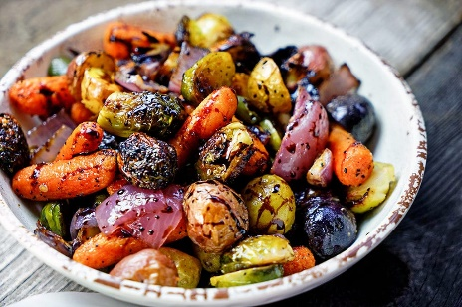
- Roast until the vegetables are tender and lightly caramelized, 25 to 30 minutes. Check each vegetable for doneness.

Examples of Vegetables to Roast:
- Carrots
- Broccoli
Seasonings/Oil to Add and Use:
- Salt
- Pepper
- Paprika
- Thyme
- Rosemary
- Garlic
- Olive/Canola Oil
- Beets
- Cauliflower
- Asparagus
- Brussel Sprouts
- Squash
- Onions
- Sweet potatoes

