

Quick and Easy Breakfast Ideas!

Overnight Oats

In a Mason Jar Add:

* ½ cup of oats
* ½ cup unsweetened almond milk or low-fat milk
* Fruit of your choice (banana/berries)
* Optional: nut butters, nuts, seeds, protein powder

*Cover, Shake, Refrigerate Overnight*

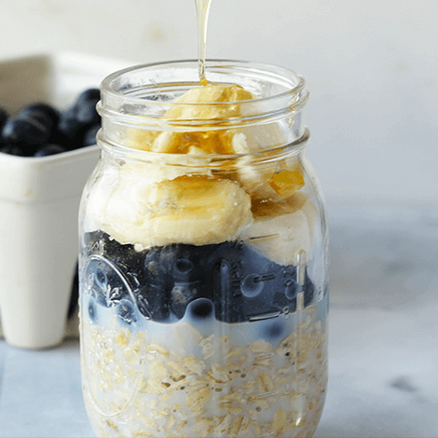

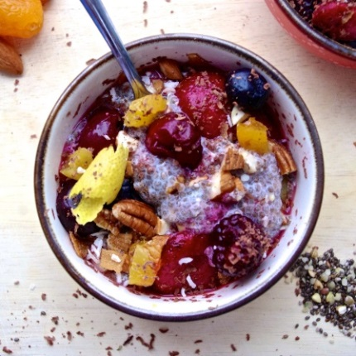

Yogurt Breakfast Bowls

* Greek yogurt
* Granola
* Fresh fruit of your choice
* Optional: nut butters, nuts, seeds
* Honey or maple syrup

Egg Muffins

* Fresh Eggs or Egg Whites
* Choice of Veggies (spinach, peppers, tomato, mushrooms)
* Low-fat cheese
* Pepper and Salt
* Bake for 20 Minutes at 350 degrees in a muffin pan